7896-009 SNAP MODULE FIRMWARE DESIGN
REV 1.00

Introduction
The SNAP module is intended to be an easy to setup interface module. It will be used to connect to a WiFi router and send status up to and receive requests from the Mars Cloud database website. It uses a GainSpan GS1011 as its access point and a STM8 microcontroller to get messages from the device that get passed through the GS1011 to the website.

This document is divided into two sections; Section 1 describes the interaction between the Device and the SNAP module micro-controller. Section 2 describes the interface between the SNAP module micro-controller and the GS1011.

SNAP Module Firmware Design Document
Document 7986-007
1 | Preliminary Release | JCU | 5/21/2013

The basic premise of SNAP:

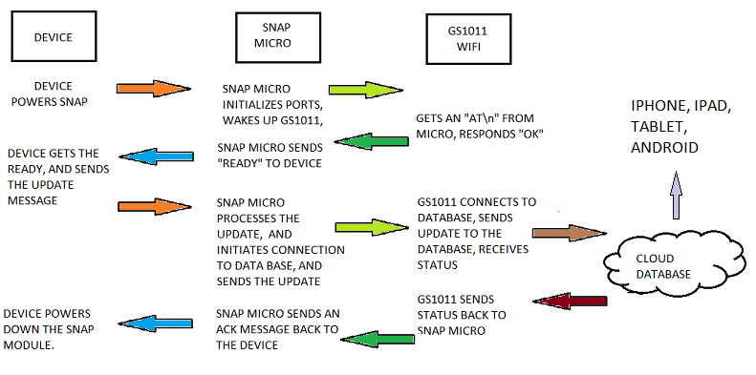

Section 1 - Device to SNAP Operation

1.1) Power Up Sequence
All communication between devices and the SNAP must use the same protocol, which is defined in 7896 -008 SNAP RS232 Communications Spec.doc. The device the SNAP module is connected to is responsible for supplying power to the module. If the device is battery powered, the device turn the power on to the module, and wait for SNAP to send a “powered” message. The SNAP will then check the condition of the GS1011, if the GS1011 has a web access point (wireless router connected to the web). It will send a status ready message to the device. If the GS1011 needs to be be configured, the SNAP will send a configuring GS1011 message.
The SNAP unit will look for status coming in from the device. Status information, especially the serial number, is essential to setting up the GS1011, if it is not configured. The micro-controller will then check the GS1011 status, and will use the serial number to check if the GS1011 is ready to communicate with the website. If it is not it will use the serial number as the access point that the customer can see as a network on a smart phone, IPad or laptop. If it is ready to communicate, the micro-controller will process the raw update information, and format it for the website. The full procedure for this sequence is in 2.3 Sending the GS1011 status updates.

1.2) Device to SNAP Protocol
In order to get the update from the device to the website, it has to go through the SNAP module micro-controller. To make the interaction between devices and the SNAP micro-controller uniform, there will be only one format for the messages. While the number and type of parameter may change with different devices, it will always follow the same rules. Below is the basic layout of the messages between the device and SNAP module.

Hex/ASCII mix:
Byte position | Value
0 | STX (02 hex)
1-2 | Packet Length
3 | Command
4 – (n-2) | Packet Data
n-1 | Checksum
n | ETX (03hex)

Where:
STX Start of Text (0x02), unique start of message. Hex
Packet Length Number of characters in message not including STX, length or ETX. Hex
Command Normally “U” for update, returned in response unless website has a request, then it will be a “R” in the response. ASCII
Packet Data Update data, if data contains STX, ETX, DLE, or comma the STX, ETX, DLE, or comma must be inverted and have DLE preceding it. Mixed
Checksum The 8-bit checksum is calculated by summing bytes 1 through n-2 and subtracting that value from 0x55. The 8 least significant bits comprise the checksum. hex
ETX End of Text (0x03).

A full explanation of this message protocol is available in SNAP RS232 Communications Spec.doc Document #7896-008

There is one hard and fast rule, the first parameter in the update message packet data MUST always be the serial number of the device. This serial number consists of 16 ASCII numeric characters, with the first six (6) containing the device class. Since different devices have different update parameters, the device class will be used to properly format the raw parameter data. Since the parameters maybe raw hex, or ASCII values, the SNAP micro-controller will need to know what type of data is in which field to guarantee the message is sent properly to the website.

1.3) Getting the Device status update
The micro-controller will, accept the raw update data from the device. It will begin by looking for a STX (0x02), and will store the data in a temporary buffer until it sees an ETX (0x03). Only valid data will be stored in the temporary buffer, which means that the ISR will check for DLE (0x10) in the stream, throw it away, set a flag, and invert the next character that comes in and store it in the buffer. It will use the length byte to determine the length of the true message characters.

Once the complete message has been saved, and the checksum checked. A flag will be set signaling the main loop that there is a valid message to convert.

1.4) Device UART Interrupt Service Routines
The STM8 will interrupt the main loop when a receive character is shifted into the port. The ISR is a state machine, the states are as follows:
State 0
Looking for an STX, if character is an STX, then save it in the buffer.
Increment the input pointer.
Change the state to 1.
State 1
Is character an ETX?
If yes, then end of message, set complete message flag and return.
Is character a DLE?
If yes, then set the DLE received flag, and return.
Is DLE received flag set?
If yes, then invert current character, save it in the buffer.
Clear the DLE received flag.
Increment the input pointer, and return.
If normal character
Save the character in the buffer.
Increment the input pointer and return.

1.5) Processing the Update Message from the device
Processing the update message from the device is dependent on which device the SNAP is attached to. While the message format may be the same, the serial number being the first parameter is likely to be the only thing they have in common. The web page is expecting the data to be in ASCII, and the device may be sending it raw hex. The SNAP micro will have several utility routines for saving the serial number in EEPROM, converting raw hex data to ASCII.

1.6) Sending the Update
Once the SNAP micro formats the message, it will setup the GS1011, and send the update to the website. The communication between the SNAP micro and the GS1011 is described in 2.3 Sending the GS1011 status updates.

1.7) Sending completion response to the Device

When the response comes back from the website, if the response is {“status”:”good”} then the SNAP micro will send an ACK message. If the status is an error message, then the SNAP micro will send a NAK message.

1.8) Potential problem areas (where errors could occur)

Obviously, there are areas where problems may occur. These include a loose cable between the SNAP and the device, low battery voltage, an out of service router, or the network being down. The SNAP micro will be able to determine when there is a problem and be able to report the problem to the device. The device must have a way of displaying the error, on a display (if one’s available), on LEDs, or whatever is used to indicate an error.

Section 2 - SNAP to GS1011 Operation

2.1) Checking the GS1011 status
Checking the GS1011 status is a little more difficult. This is because there is no ETX to indicate the end of the transmission from the GS1011. It is possible to have multiple carriage return/line feeds in a message, so the best way to handle these responses is to design a response handler for the different type of messages. Most of the responses end in either “OK” or “ERROR” followed by a carriage return/line feed. In some responses, you have to save a CID (Connection ID), an IP address, a ESC sequence and the status of the connection.

2.2) Setting the GS1011 to connect to the website
The firmware will be able to determine if the GS1011 has access to a WiFi router. If the there is a sequence of commands that must be followed in order to connect to the router. When powered up the micro-controller will send the following commands to get and check the status of the GS1011:

2.2.A Checking the GS1011 status
Disassociate (AT+WD command) Puts the GS1011 into a known state.
Get the current Network settings (AT+NSTAT=?)
Check the response
If “WSTATE=CONNECTED”
If find SSID in status response.
If SSID = device serial number then
Set the connection to a WiFi Router.
Else
Send the processed update to the website.
Else if “WSTATE=NOT CONNECTED”
Set the connection to a WiFi Router.

If the GS1011 is connected to a WiFi router, then the SNAP micro will process the update, setup the GS1011 for transmitting, and send the update through the GS1011 to the website. The procedure to do this is described in 2.3 Sending the GS1011 status updates.

If the GS1011 is not connected to a WiFi router with internet, it must establish a connection. In order to do this the user needs a phone with WiFi capabilities and a browser, as well as know the serial number of the device the user wants to set up. The serial number will be printed on a label and will be easily accessible to the user.

2.2.B Setting the Connection to a WiFi Router
To set the WiFi router the GS1011 will need to be put in a limited access point mode. The sequence that the SNAP micro sends to do this is as follows:

Do a factory reset (clear all old settings),
Reset the GS1011 (AT+RESET)
Disassociate the network. (AT+WD)
Set a default IP address.
(AT+NSET=192.168.1.1,255.255.255.0,192.168.1.1)
Set Web Access Mode to 2, Limited (AT+WM=2)
Set DHCP Server mode (AT+DHCPSRVR=1)
Set Provisioning (AT+WEBPROV=,,,2,,1)

The micro-controller will then wait for the user to use the onboard GS1011 website to select the WiFi router to use for the web connection. The GS1011 has a built in webpage that handles its connection to a WiFi router with an Internet connection. The user uses the general settings page on an IPhone or other Internet equipped phone. The user selects the local network that has the name that co-responds to the serial number of the device.
The user then goes to the browser, and types in http://192.168.1.1/gsclient.html as the location. The following screen will be displayed:

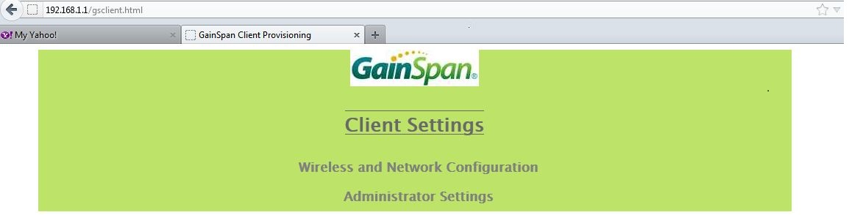

The user clicks on Wireless and Network Configuration, and the next screen is displayed:
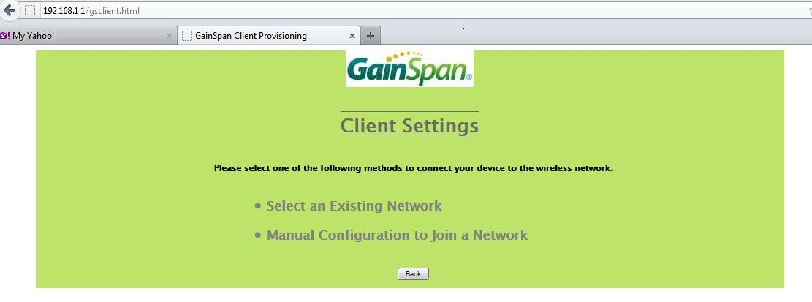

The user selects Select an Existing Network, and the next screen is displayed:
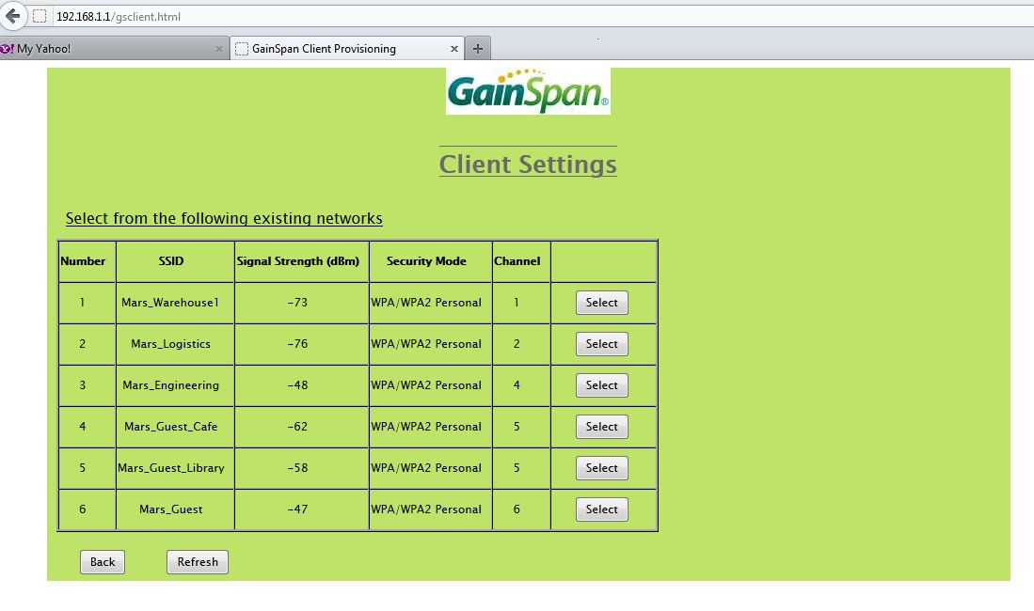

Above is a list of the networks available at the Mars International offices. It should be noted that if the user wants to use a particular network the user MUST know what the passphrase is for that network (if one is used). The user clicks on the Select button next to the network the user wants to use, and the following screen will appear:
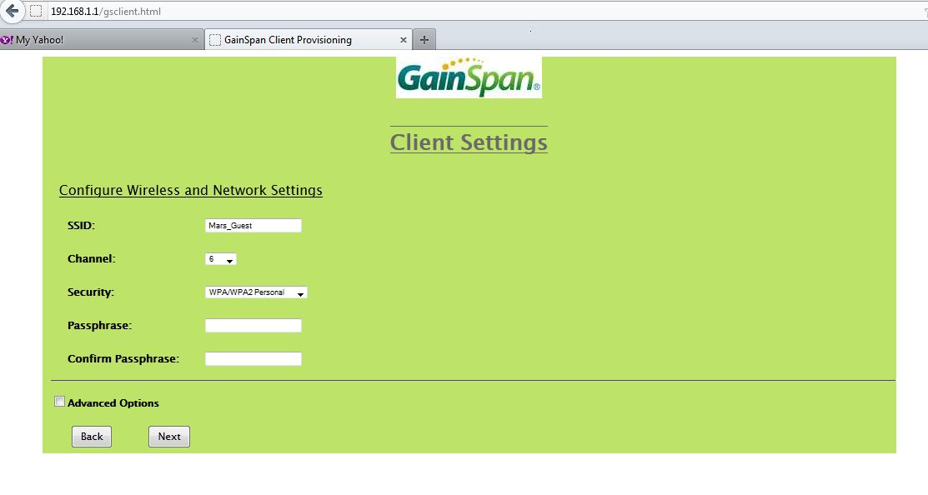
The user will then enter the passphrase for the network, confirm the passphrase and click Next. The next screen will be displayed:
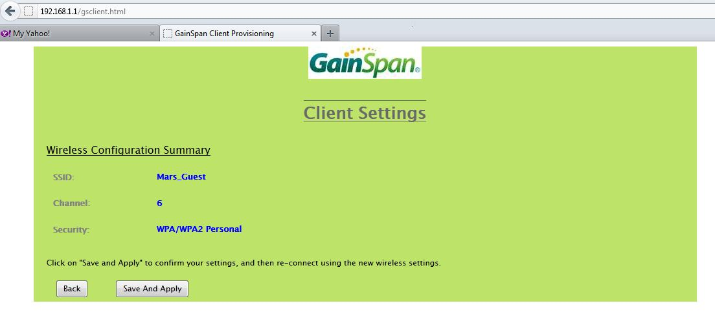
The user will then click Save And Apply, the GS1011 will then send a profile back to the SNAP micro that includes the settings for the network. When the response is received, the SNAP micro will save the SSID of the WiFi router as well as its passphrase. The SNAP module is now ready to send updates to the website.

2.3) Sending the GS1011 status updates
Status from devices differ by the device type, the device class defines this type. The device class is the first 6 numbers of the serial number, which means there can be 999,999 device types. The device class for the EHRT has been “000000” in most of the demos so far. Note that the status examples below are for the EHRT.

The status update from the device needs to be processed into the format the database website can handle. The first time sending an update message the sequence of commands must be followed:

Look up the IP Address of the website (AT+DNSLOOKUP=mars.bwgrp.com).
Save the IP address in IPAddressString.
Set the type (AT+HTTPCONF=11,mars.bwgrp.com).
Set the keep alive, otherwise will disconnect (AT+HTTPCONF=3, keep-alive).
Open the IP address (AT+HTTPOPEN=" & IPAddressString).
Save the CID.

Send the update (NOTE: This is a status message for the EHRT) (AT+HTTPSEND=0,1,100,/account/api/setdevicelog/p1/0000001234512555/p2/1.2345/p3/D/p4/S/p5/S/p6/D/p7/00078901/p8/345678/p9/000789/p10/21221/p11/3.2222/p12/3.1111/p13/0/p14/0/p15/0 )
(The 0 above is the CID. The AT+HTTPSEND=0,1,100,/account/api/setdevicelog is the header that all device updates will use.)

Get the response, from 2.4 Checking the GS1011 status response.

2.4) Checking the GS1011 status response
The response from the GS1011 will look something like this:
H00025200 OK
{"status":"good"}
OK
The micro-controller will look for the left-brace { for the start of the response from the website. If the result is “good” the micro-controller will send an ACK to the device.

